Visida App Process:

Food Record: Represents a single day’s worth of food intake.

Eating Occasion: Represents a single eating session ie lunch, dinner, snack. An eating occasion will have food items added to it for 1 hour. After an hour, a new eating occasion will be used.

Food Item: Represents a single piece of food. Ie Apple. Food Item’s contain an image and audio recording for both the initial food item and another for any leftovers.

The app builds the Food Record, Eating Occasion, Food Item data structure as the user captures the data. Once the user has selected a Capture Feature (Own Plate, Shared Plate) they are presented with the list of participants stored in the device. Upon selecting the House hold member to capture for, a Food Record for that day is created, if one already exists it is used. Also when a house hold member has been selected the eating occasions for the food record are checked for the “current” eating occasion. Current here is defined as an unfinalized eating occasion which began within the last hour.

Creating a regular Food Item involves taking an image and voice recording. The Camera Activity expects two extra fields: SHARED_DISH and ALLOW_NO_IMAGE, The shared dish Boolean is used to determine what file name template is to be used for the image. The ALLOW_NO_IMAGE controls whether the no image button is available on the screen. The camera activity will return RESULT_OK with the extra field IMAGE_NAME containing the string with the file name of the image. The returned file name will only be the template, it is the responsibility of the Calling activity to fill the image file name out. Recording audio works similar, the Audio Activity expects four extras, IMAGE_NAME to display the image, SHARED_DISH doesn’t control anything at the moment. AUDIO_FILE_NAME contains the file name to record the audio into. ALLOW_TEXT controls whether the text option can be used. Currently Text is only available in the Australian version. The Audio recording will be stored in the provided file and the file name is returned. It is the responsibility of the calling activity to fill out the filename template and update the data in the database.

Creating a Meal. When Shared plate is selected a special Eating Occasion is created with a Meal Id. The food items are added to the meal Eating Occasion in the exact same way as the regular eating occasion. Once the user selects the Finalise option the meal is converted in individual eating occasions. Each household member will have a new Eating Occasion created (or have the food items appended to the most recent if one exists within the last hour). Every food item within the meal is copied into the respective eating occasion for each household member. The Image and Audio files are shared.

**Notifications.** There are two main kinds of notifications in the app.

* Finalise Eating Occasion: A reminder to finalise an eating occasion reminder is scheduled to go off 1 hour after the first food item is added to the eating occasion.
* Record Review: The record review notification is scheduled in the system at the same time as the finalise eating occasion notification (when food item is added). However, the time for the notification to alert the user is set during the household setup process (default is 7:30pm). Record review notifications can be accessed via the Bell Icon on the main activity. The bell icon will open a menu containing each of the Food Records to review. The items will remain in this list until midnight of the day the food record is created.

**Instructions.** The instructions for each page are written in resource xml files in the form of string-array’s. Each language’s instructions are in their corresponding directory (km-rKH, sw-rTZ). The corresponding media files (image, audio, soon to also include video) are in the instruction_media xml. The media xml does not have a translation, to accommodate different languages the media has translated *drawables* in their respective languages *drawables* directory.

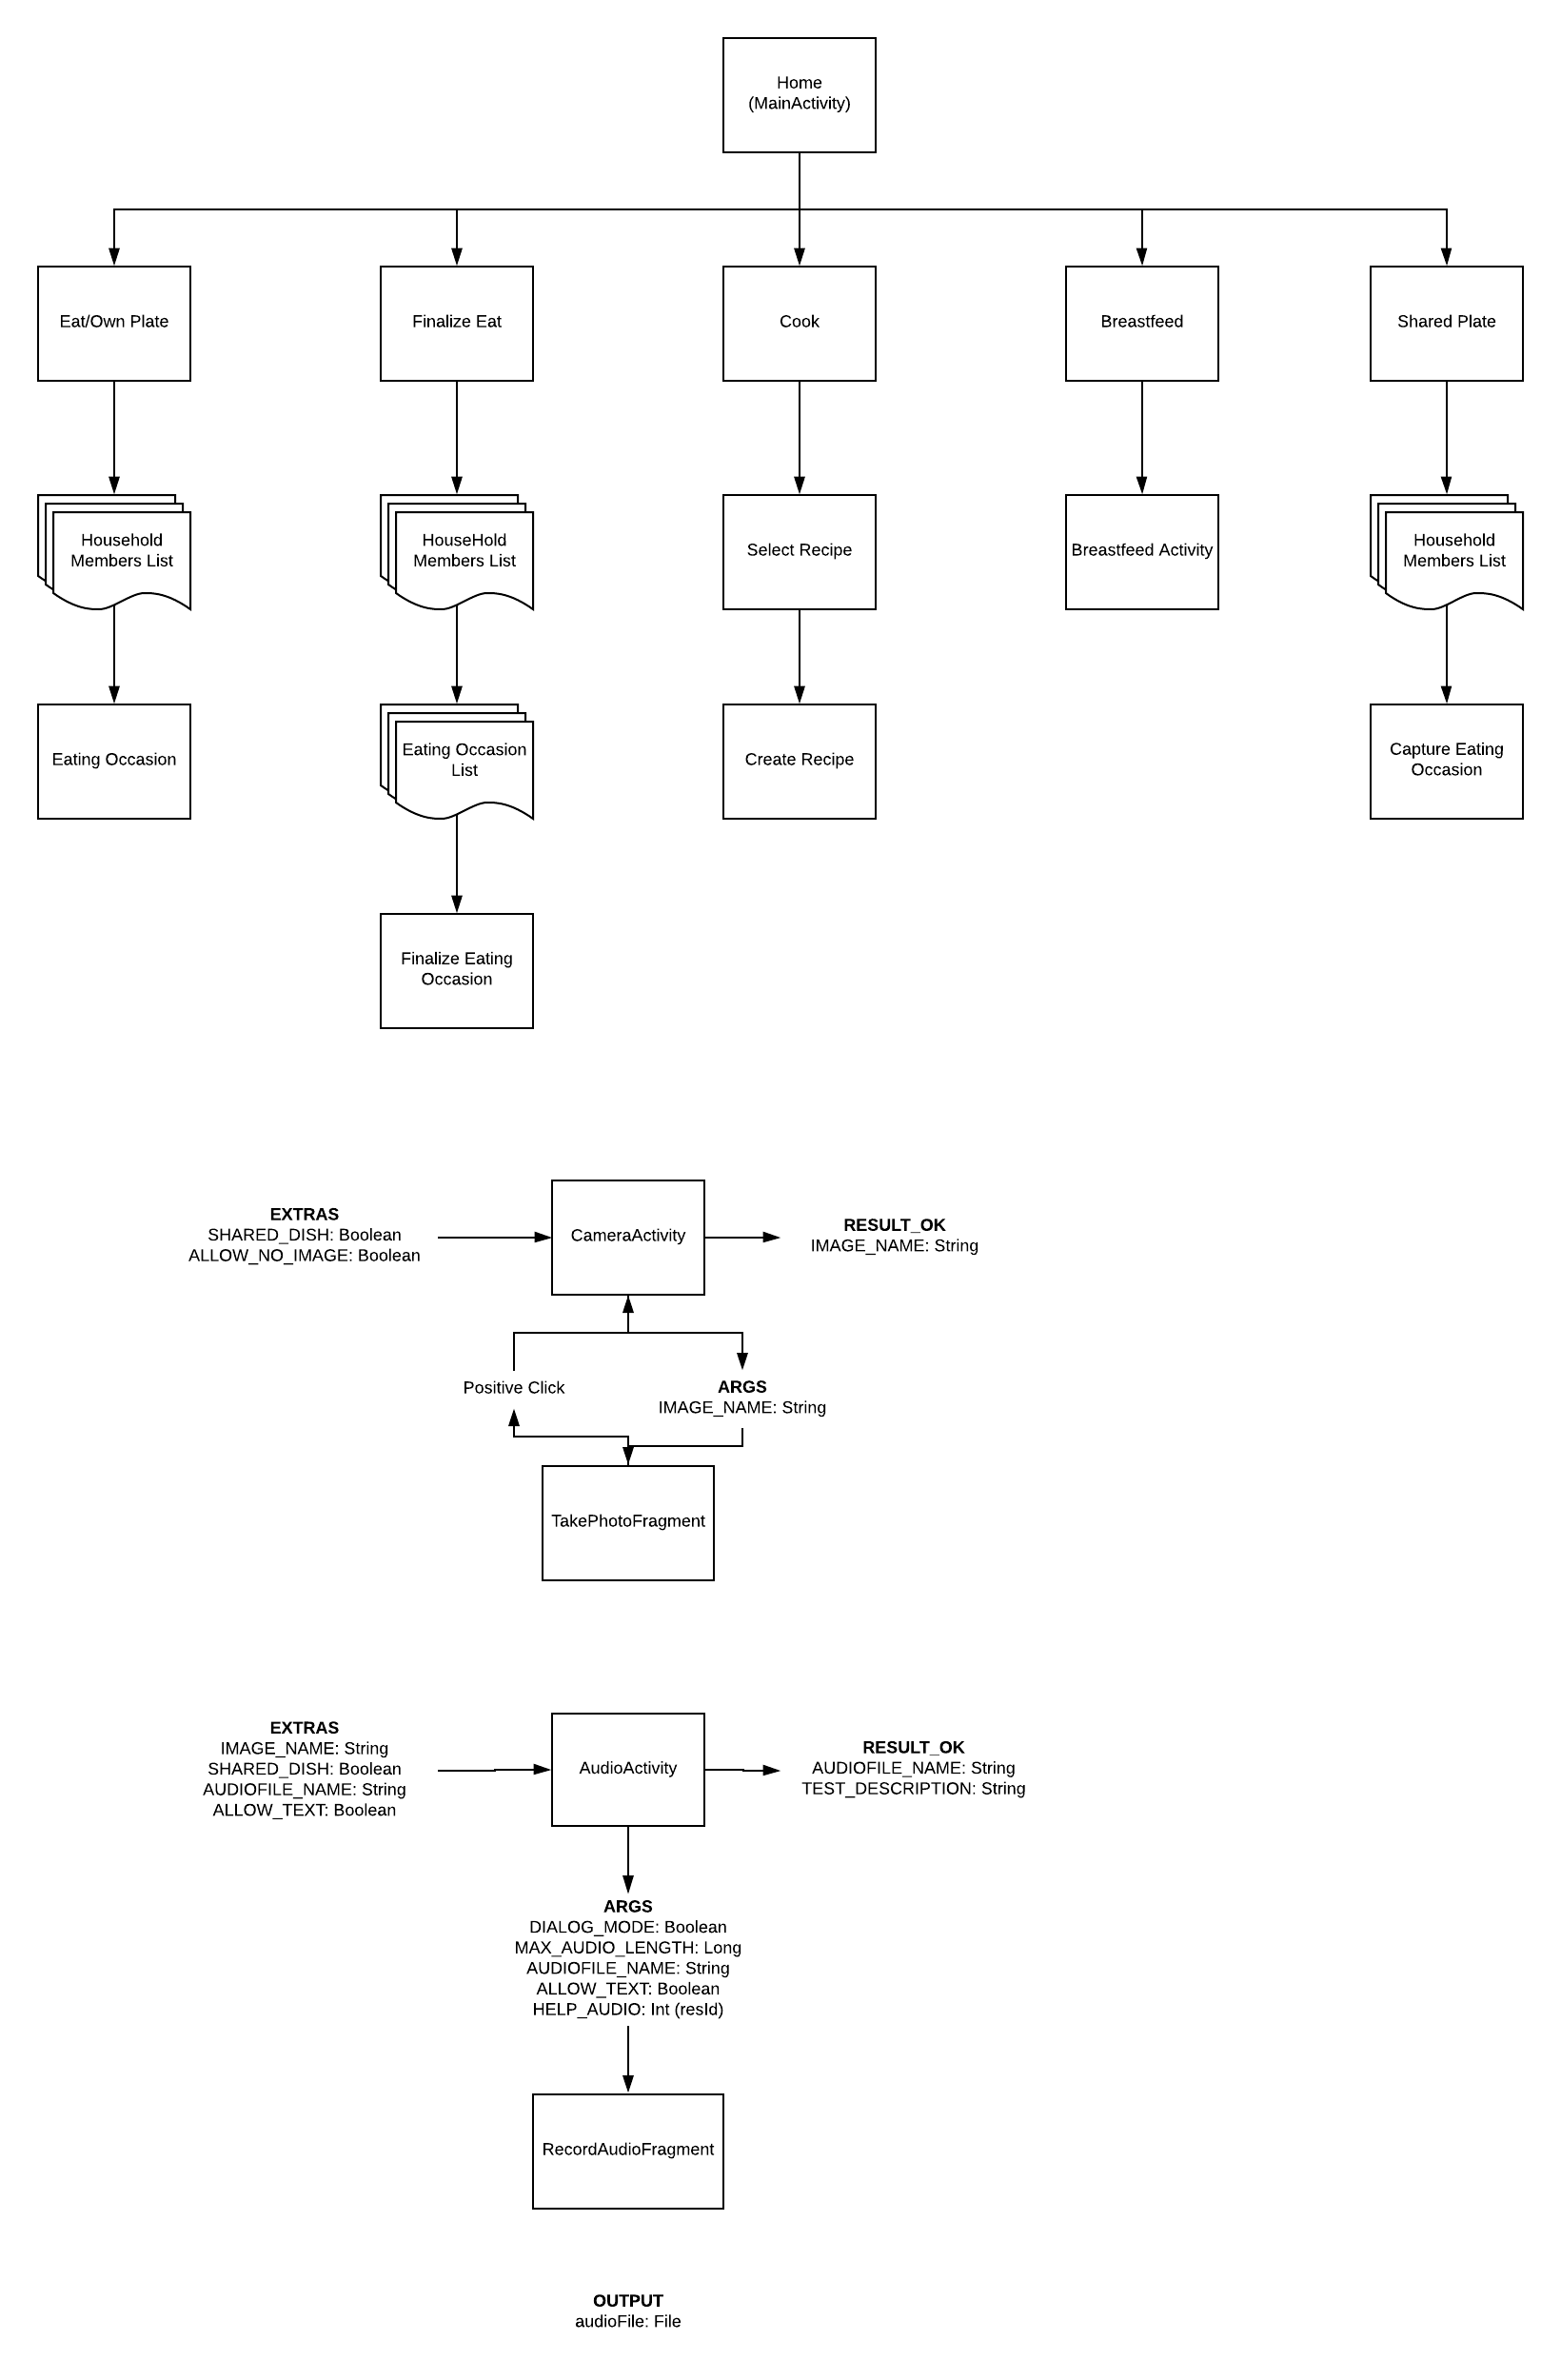

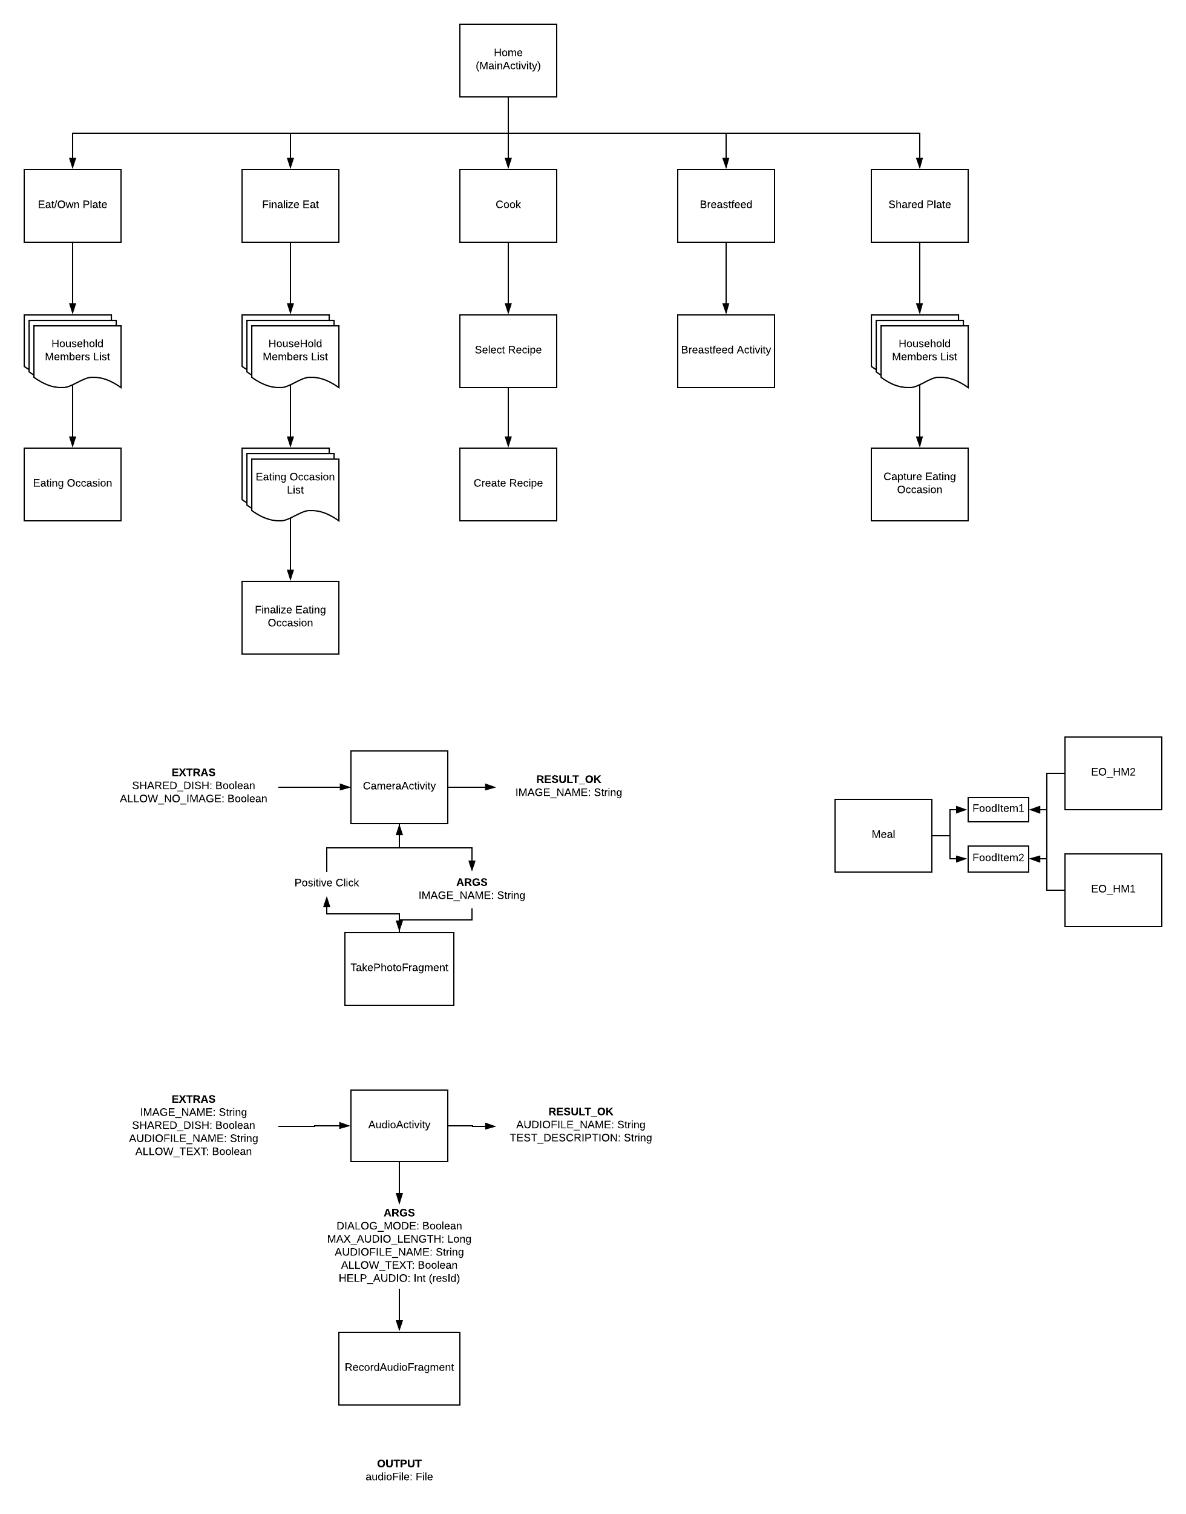

|  |  |  |  |
| --- | --- | --- | --- |
| **Starting Activity** | **Destination** | **Intent** | **Trigger** |
| MainActivity | SetupHouseholdActivity |  | Shared Preferences value for “SETUP” is false. |
| MainActivity | SelectHouseholdMemberActivity |  | User clicks, EAT or FINALIZE |
| MainActivity | ListRecipeActivity |  | User clicks COOK |
| MainActivity | MealActivity |  | User clicks SHARED PLATE |
| MainActivity | RecordReviewActivity | FRID – Id of food record to review | User clicks notification from bell menu. |
| MainActivity | SettingsActivity |  | User clicks COG |
| SetupHouseholdActivity | CreateHouseholdMemberActivity | HOUSEHOLDMEMBER – Household member to edit (pre fill fields). If null, don’t pre fill fields. | User clicks an existing household member. |
| SelectHouseholdMemberActivity | MainActivity |  | State is INVALID |
| SelectHouseholdMemberActivity | EatingOccasionActivity | FR – Food record for the household member | State is EAT |
| SelectHouseholdMemberActivity | SelectEatingOccasionActivity | UNFINALIZEDEOIDS – Long[] of Eating occasion ids for eating occasions are not finalized | State is FINALIZE |
| SelectHouseholdMemberActivity | BreastfeedActivity |  | State is BREASTFEED |
| SelectHouseholdMemberActivity | MealActivity |  | State is MEAL |
| ListRecipeActivity | CreateRecipeActivity | RECIPEID – Id of a recipe to edit. If not provided a new recipe is created. | User clicks a recipe |
| MealActivity | CameraActivity | Starts activity for result | User clicks Add Food Item |
|  | MainActivity |  | User clicks finish |
|  | Audio Activity | IMAGE_NAME – The path to the image just taken.  AUDIO_FILE_NAME – The name of the audio file. | Image has been returned |
| RecordReviewActivity |  |  |  |
| SettingsActivity | SetupHouseholdActivity |  | User clicks set up household |
|  | RecordVerificationActivity |  | User clicks verify |
|  |  |  |  |
|  |  |  |  |
|  |  |  |  |
|  |  |  |  |
|  |  |  |  |
|  |  |  |  |
|  |  |  |  |
|  |  |  |  |
|  |  |  |  |
|  |  |  |  |
|  |  |  |  |